Commercial Configured Decoder Instructions

10/23/2006

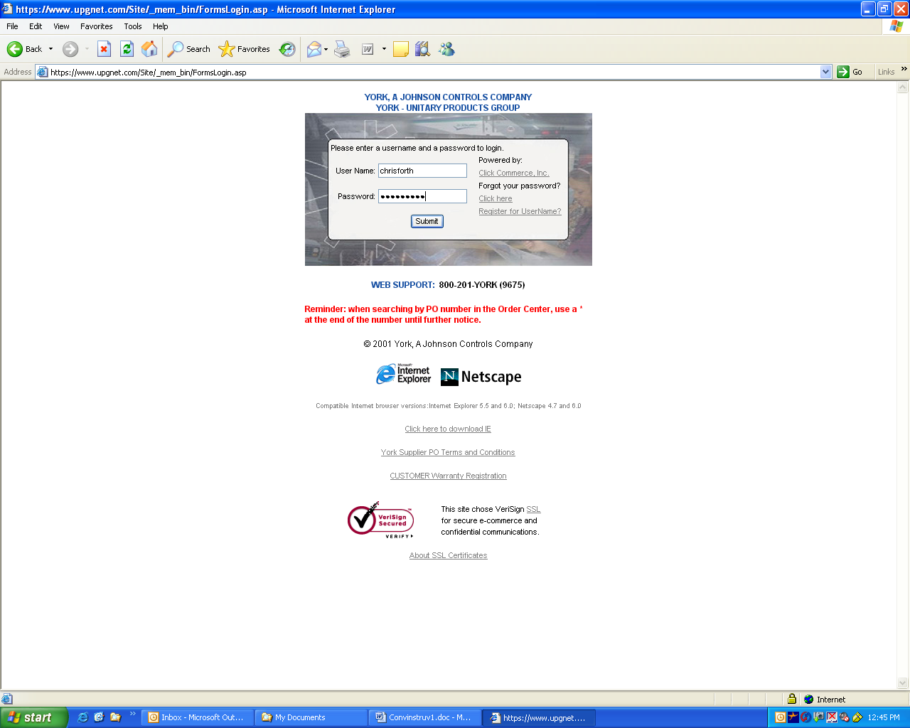

1) Open Internet Explorer and type in www.upgnet.com and hit Enter / Return

2) Enter a valid User Name and Password and then click on the “Submit” button

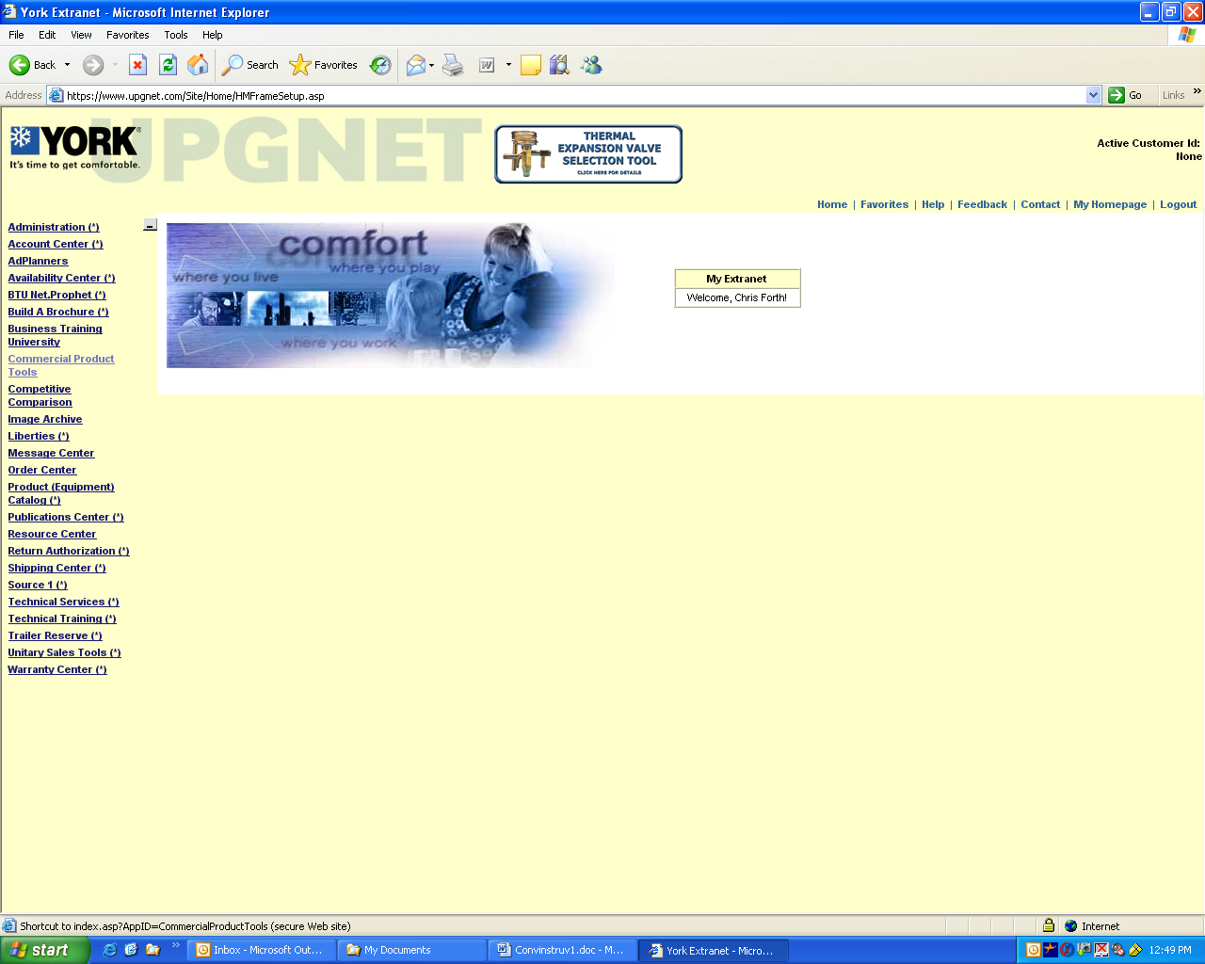

3) Click on the “Commercial Product Tools” link

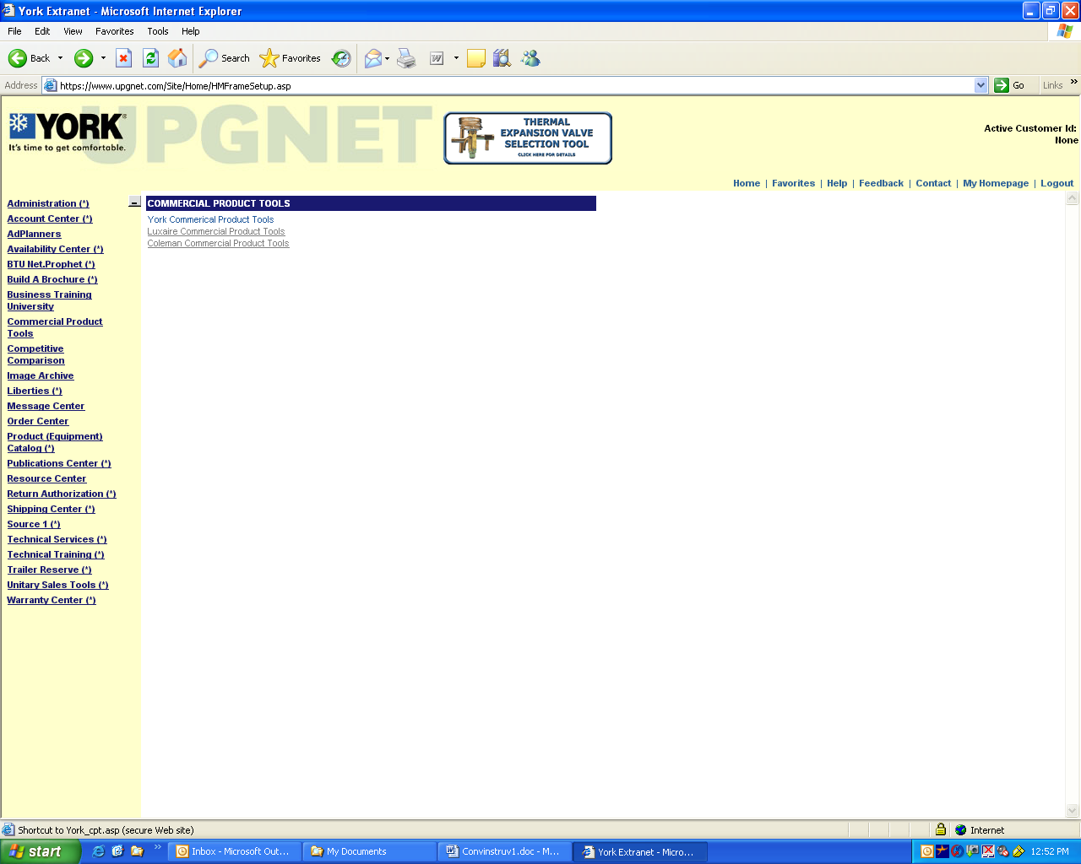

4) Click on the appropriate product brand link (in this example “YORK”)

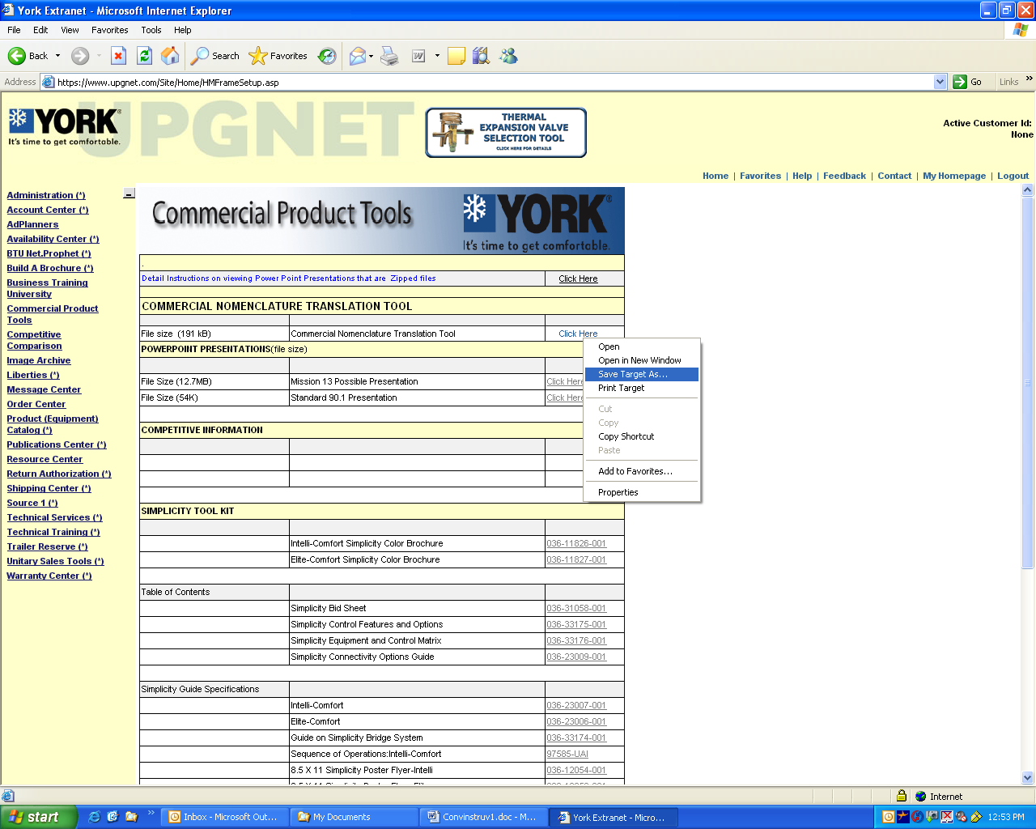

5) Right Click on the “Commercial Nomenclature Translation Tool” link labeled “Click Here”.

6) Select the “Save Target As” menu item

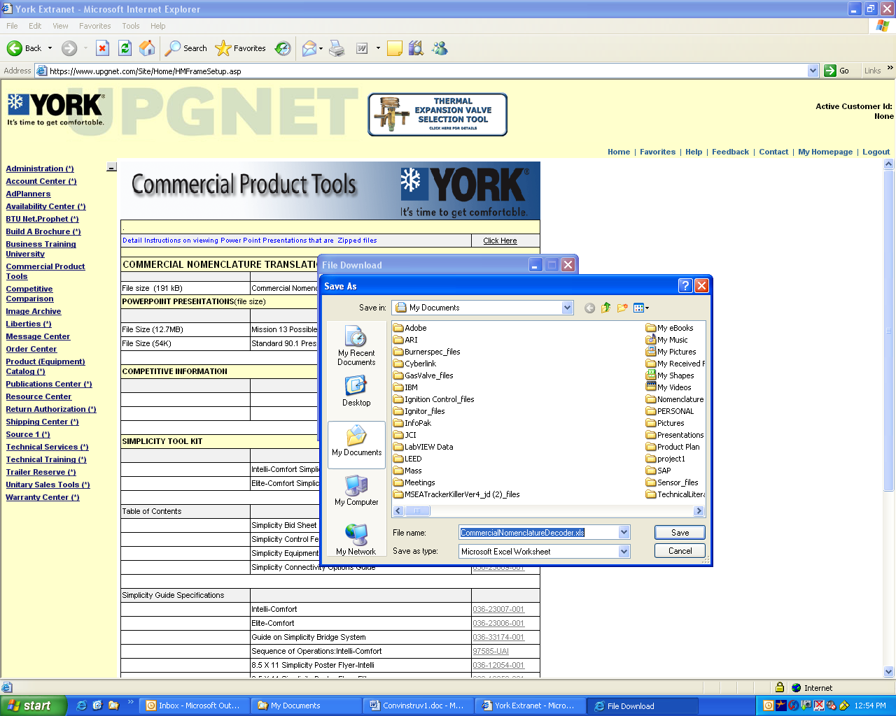

7) Pick a location on your local drive to save the file. In this example “My Documents”

8) Click “SAVE” using the default file name

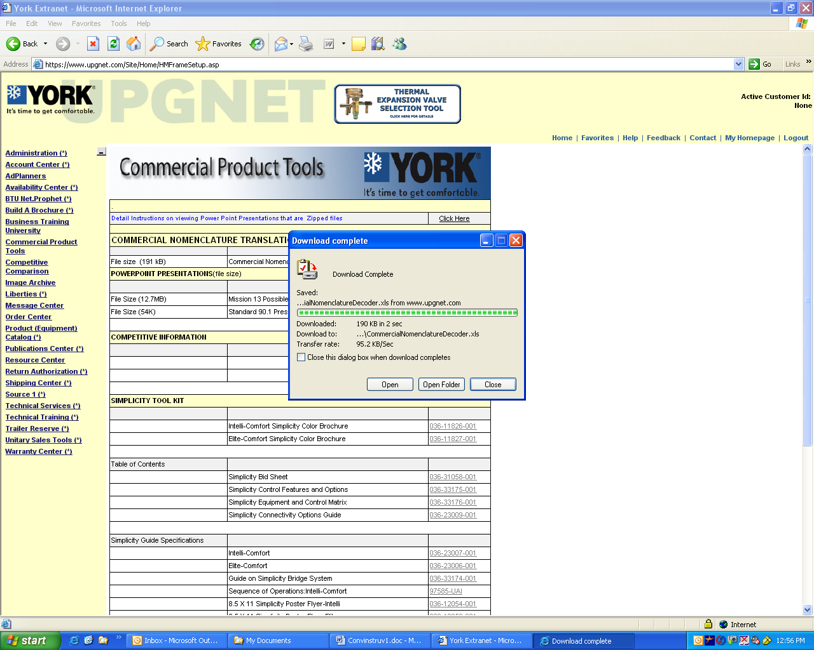

9) Once the file completes downloading, Click “OPEN” to run the Excel Application

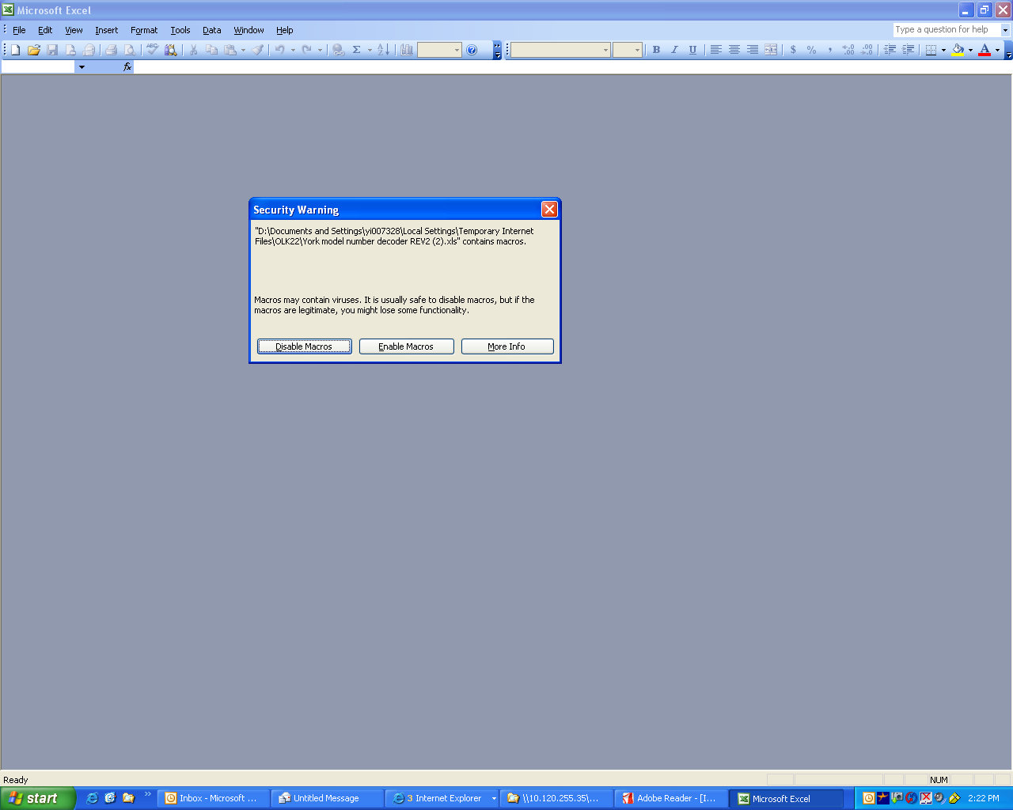

10) If prompted, Click on “Enable Macro’s” to allow the program to work.

Note:
If you do not get prompted to enable macros see the instructions at the end of this document on how to enable macro’s in Excel.

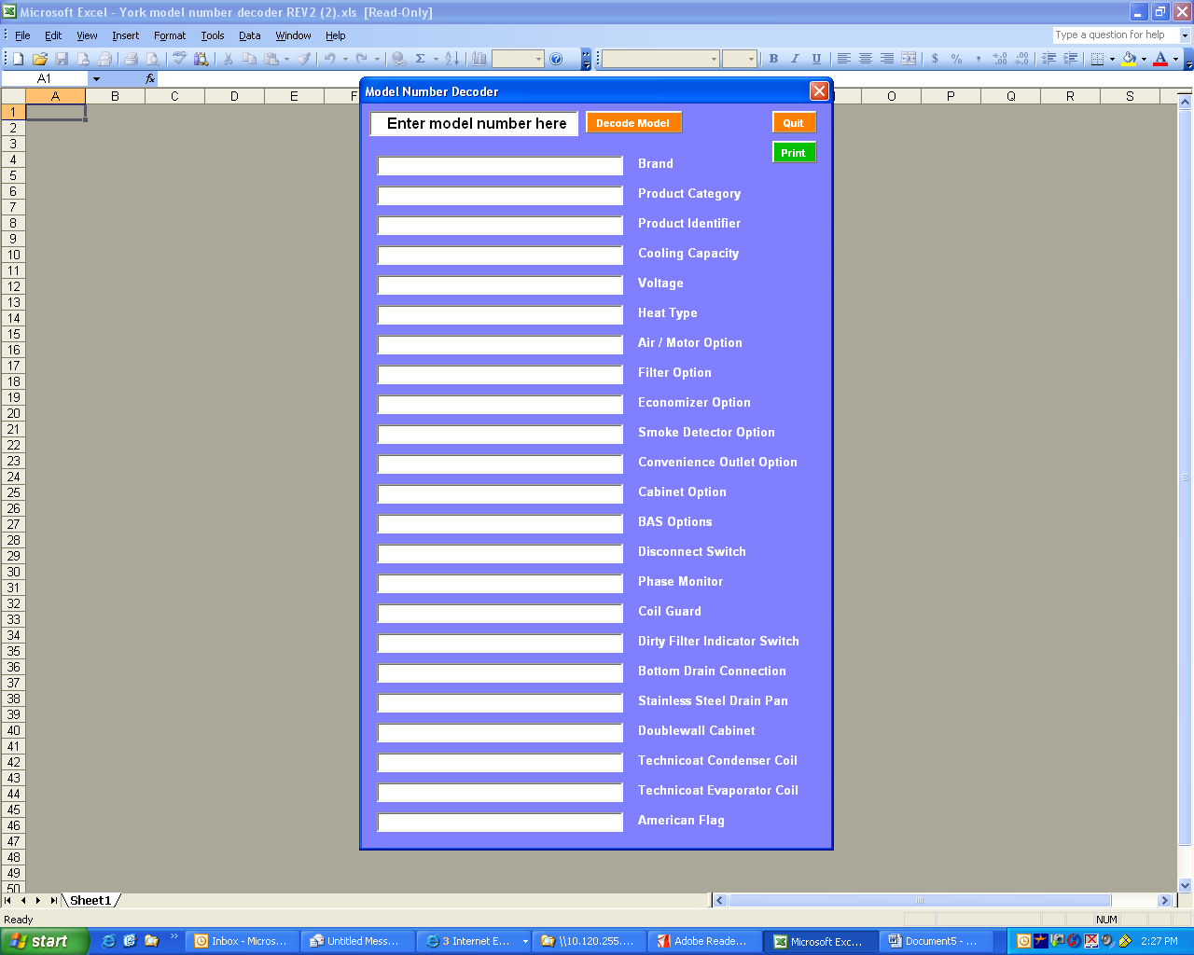

11) Enter a “valid” 14 digit model number (e.g. DJ060N06P4DAK2, overwrite the existing text).

12) Click the “Decode Model” button and the program will break down the model for input into www.upgnet.com / Order Center (aka SAP Internet Sales)

Note:
Use “Ctrl V” to paste models copied from other applications

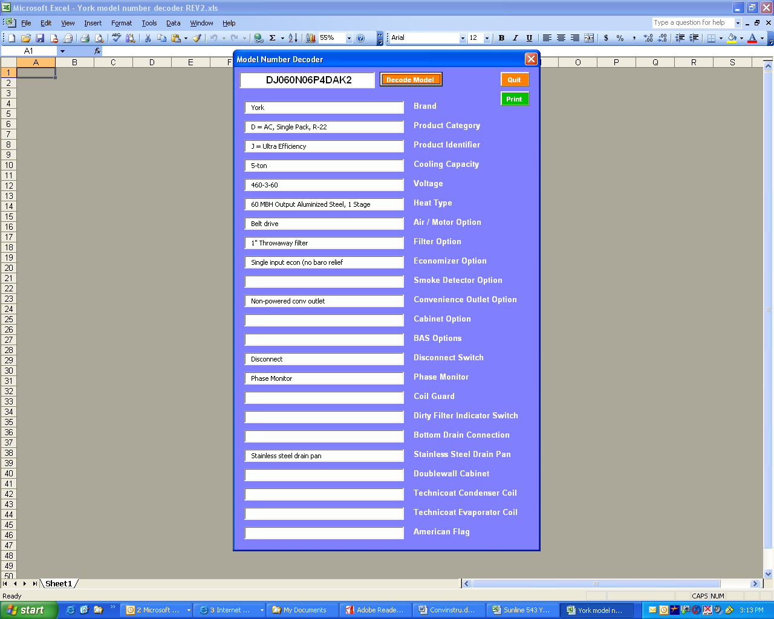

15) Click “Quit” to end the program
To copy model numbers, erase the existing model and use “Ctrl C” to copy and “Ctrl V” to paste

14) Click “Print” and use the list for input for the “Order Center”

13) Enter each of these value into the appropriate “Order Center” screen on www.upgnet.com

Instructions for Enabling Macros in Excel

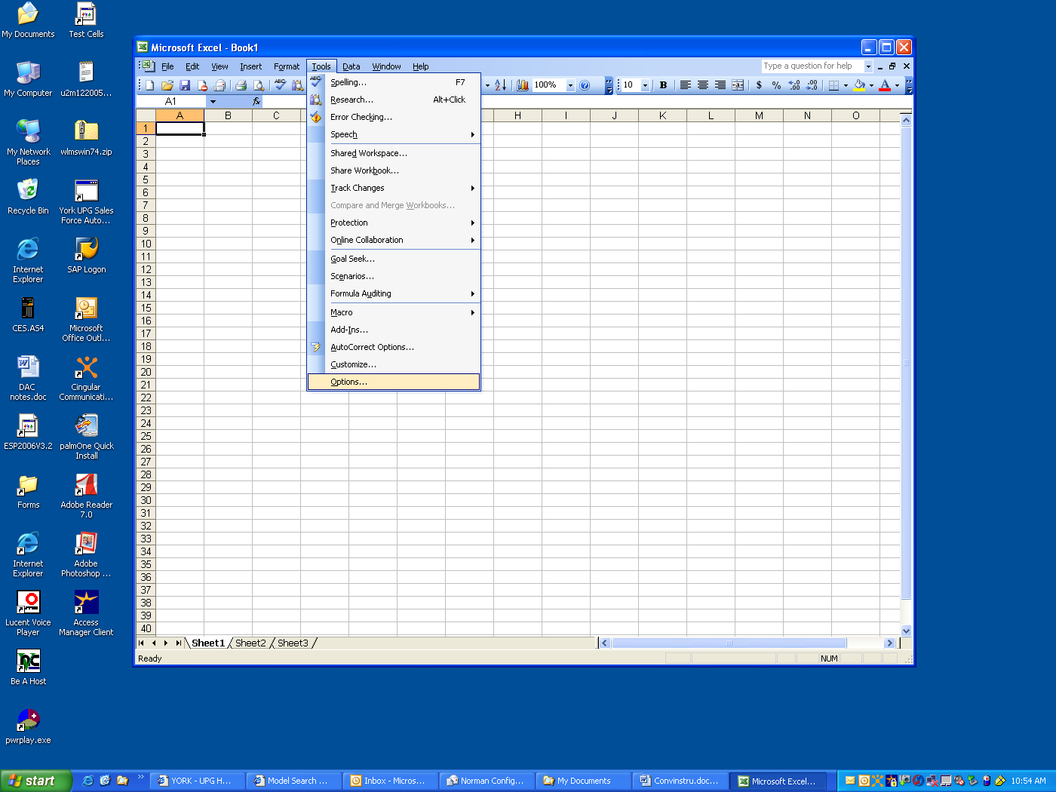
1) Click on “Tools”
2) Click on “Options”

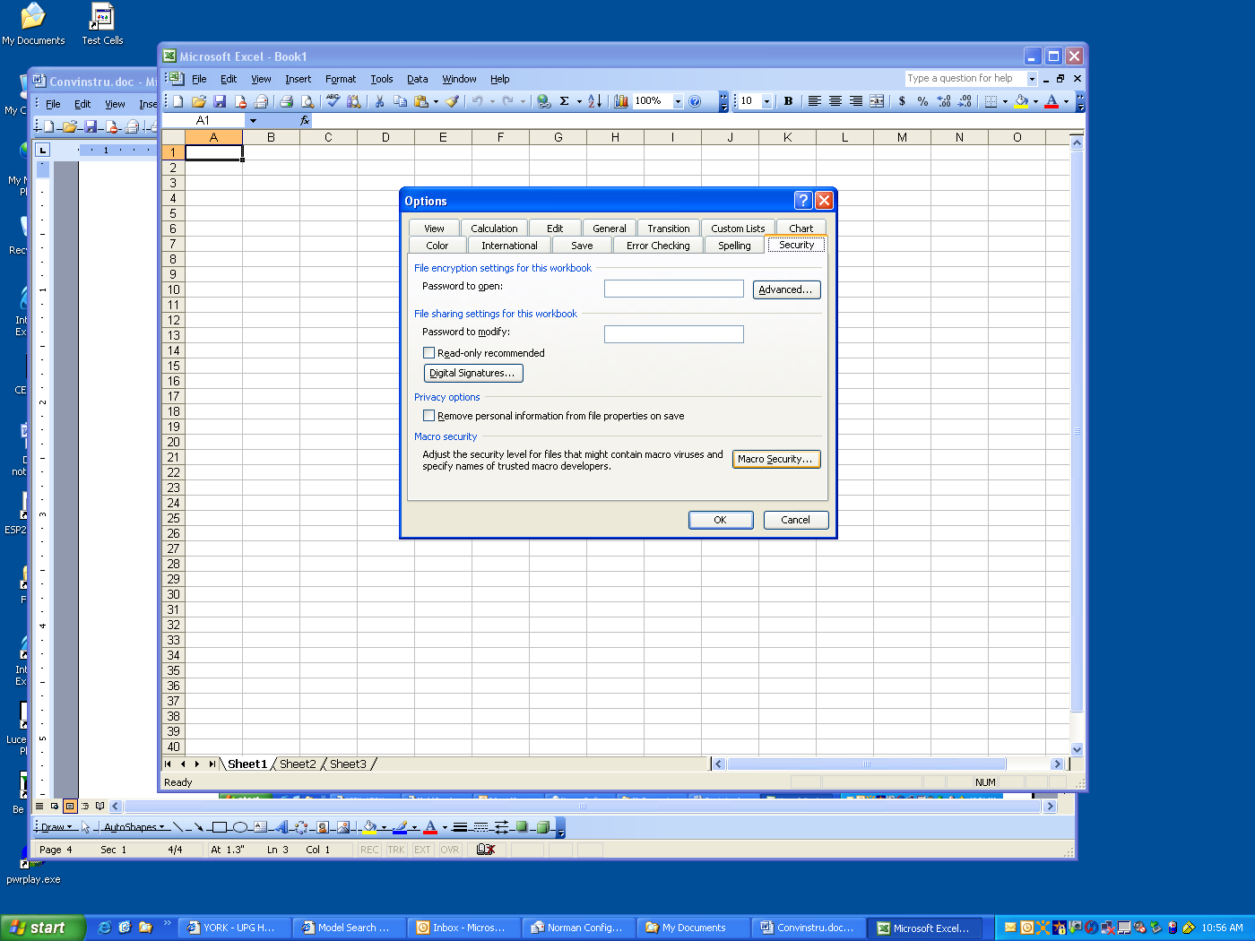
3) Select the “Security” tab
4) Click the “Macro Security” button

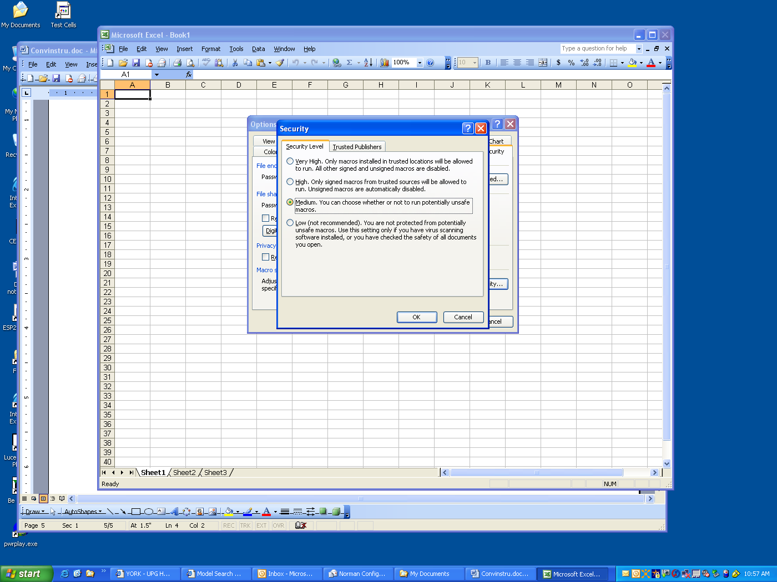
5) Select the “Medium” security button
6) Click the “OK” button

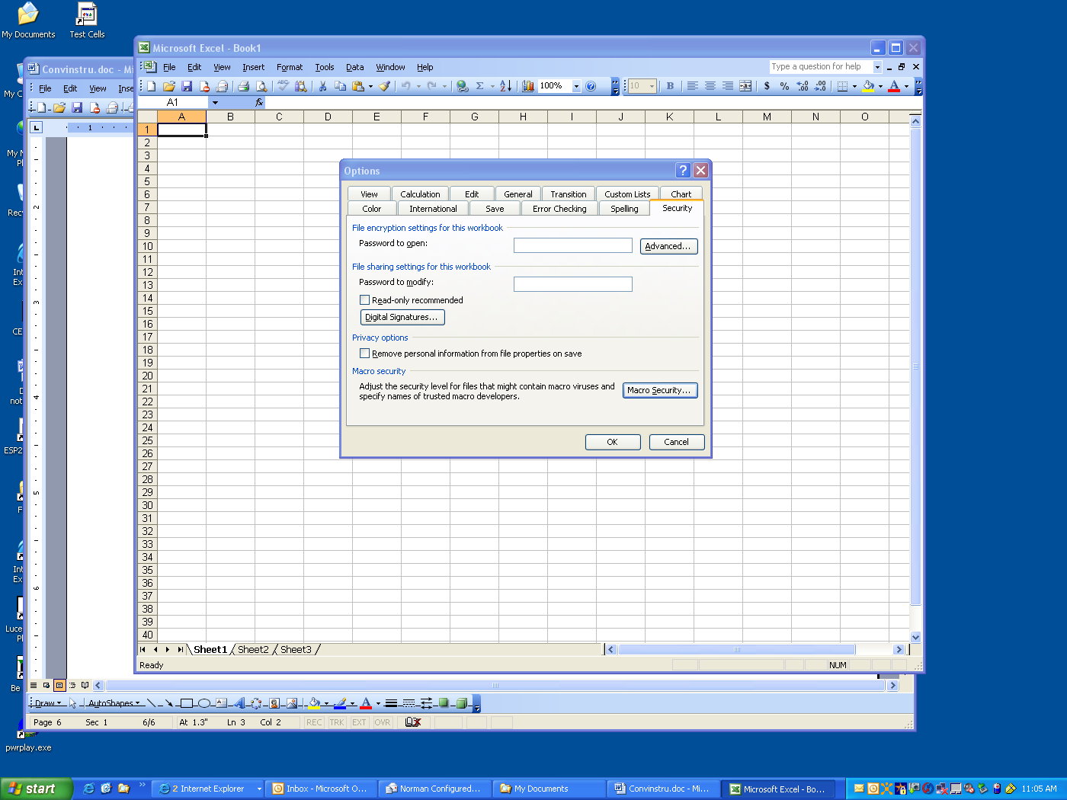
7) Click the “OK” button again.

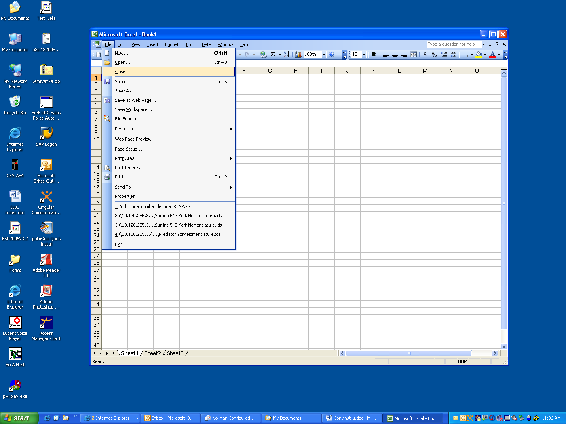
8) Select “File” and then “Close”
Note:
Restart the application for the Macro change to take affect and follow the instructions from the beginning.

